THE GANN WHEEL IS A SQUARE ROOT CALCULATOR
The Gann Wheel, what most people probably think of as the Square of Nine, is sometimes called a "Square Root Calculator" or a device that "Squares the Circle." This simple illustration may explain how and why these terms came about. You probably recognize that the illustration is just the first few rings of a Gann Wheel with the numeral "1" at the center.
31 | 32 | 33 | 34 | 35 | 36 | 37
30 | 13 | 14 | 15 | 16 | 17 | 38
29 | 12 | 13 | 4 | 5 | 18 | 39
28 | 11 | 2 | 1 | 6 | 19 | 40
27 | 10 | 9 | 8 | 7 | 20 | 41
26 | 25 | 24 | 23 | 22 | 21 | 42
49 | 48 | 47 | 46 | 45 | 44 | 43
In Square of Nine parlance we say things like 19 is 90 degrees from 15. That makes sense only if you can visualize that this rectangular table of numbers is enclosed in a circle (or series of circles) of 360 degrees. In this case, the number 19 is 1/4 the way around the circle from the number 15, or 90 degrees in circumference from 15. The number 34 is directly above the number 15 and positioned one circumference or one ring outside the circle that contains the number 15. In the same sense that we can say that 19 is 90 degrees from 15, we can say that 34 is 360 degrees from 15, or one complete rotation of the circle from 15. That explains where squaring the circle comes from. A more accurate expression would be that we're circling the square but that never did catch on.

HOW TO ROTATE AROUND THE GANN WHEEL
Here's where it gets fun. The square root of 15 is 3.87. Add two to the square root of 15 and we get 5.87. Square 5.87 and we get 34.49 which rounds to 34. Now we know that adding two to the square root of a number and squaring that sum is the same thing as a 360 degree rotation up on the Gann Wheel. If "2" represents a 360 degree rotation then "1" represents a 180 degree rotation, "0.5" a 90 degree rotation, and so on. W.D. Gann tells us that 90 degrees in very important in the stock market. What Gann is really saying is that adding and subtracting .5 (and exact multiples or proportions of .5) to the square root of a stock price and then squaring the result is very important! We acknowledge that there is is another school of Gann thought that will say that Gann's reference to 90 degrees relates to the movement of celestial bodies. We've looked into that and they may be right, but for our purposes we've also learned that these schools of thought can peacefully exist alongside each other without contradiction.
A very few people have been using some variation of the Gann Wheel for about 100 years now. In his now famous interview given to Richard D. Wyckoff in 1909, W.D. Gann attributed market movements to some undefined "law of vibration." People can disagree about what W.D. Gann meant by that but we, at least, are fairly certain he was talking about the principles underlying the Square of Nine.

WHAT IS SO SPECIAL ABOUT THE SQUARE OF NINE ?
The Square of Nine is unique because unlike every other method of technical analysis, the Square of Nine is totally indifferent to whether the input variable is a price, a range of prices, or a number of trading days or calendar days. They are all the same and completely interchangeable.
Say what? That can be a little hard to get your brain around after spending years studying chart patterns, exotic moving averages, and oscillators. That's the beauty of it. Price and time become interchangeable by converting them to degrees of a circle. Squares and square roots are part of that process. Once price and time are conceptualized in degrees of concentric circles we could care less about their magnitude. At that point we care only about their orbital relationship. Are they in opposition, conjunction or square?
Is this what W.D. Gann meant in that Wyckoff interview when he said "just as the pendulum returns again in its swing, just as the moon returns in its orbit, just as the advancing year over brings the rose of spring, so do the properties of the elements periodically recur as the weight of the atoms rises." One other very special aspect of the Square of Nine is that the more you study the more you learn how much you don't know!
HOW TO
TRADE THE SQUARE OF NINE
WITH A CALCULATOR AND A PENCIL
Any mention of WD Gann is usually preceded or followed with 'legendary trader.' I suppose that's appropriate because no other stock or commodities trader, R.N. Elliott excepted, has achieved near cult status. The biggest difference between Gann and Elliott is that the latter published his work and freely divulged his "secrets." $5,000 courses notwithstanding, Gann never did. In a 1922 interview when WD Gann was asked to reveal the cause behind his incredibly accurate time factor, he responded, "That is my secret and too valuable to be spread broadcast. Besides, the public is not yet ready for it."
WD Gann was many things. Above all he was a prolific researcher and writer. Unfortunately much of what Gann wrote, as well as much of what has been written about him, is so mystifying, complicated, and convoluted that most Gann students give up disappointed in spirit and lighter in the wallet. I have paid more for one Gann book than I did for my first car, and the car was a lot more useful! Most of what's available on the Gann Wheel and the Square of Nine is no exception.
WD Gann is reported to have carried two pieces of paper onto the stock and commodities trading floor. A 9x9 table of the numerals 1-81, and a table of numerals that has come to be known as the Gann Wheel. He specially configured for the day's activities. WD Gann sold a variety of trading courses for more than 50 years and so far as we know not one of them ever explained in detail what he did with that 9x9 table or with that other table of numerals, or anything else related to the Square of Nine. Maybe he thought nobody would believe him.
We traveled the usual hyper expensive Gann book route and departed disappointed in spirit and lighter in the wallet but captivated with Gann's comments like " When price and time square change is inevitable " - captivated enough to gather all the fragments of information we could find in WD Gann's work and in others that had had written about the Square of Nine and the Gann Wheel and how it could be applied to stock, options and forex trading. I do not recall a Eureka Moment but at some point it all came together after we were introduced to an uncomplicated formula that converted price and time to degrees of a circle. Out went the Gann Wheel, the overlays, and table size charts for a cheap calculator and a pencil. We found some Square of Nine magic and never looked back! It is a good feeling when people tell us they got more out of our little ebook than the stuff they spent literally thousands of dollars on.
It's a difficult concept to get your mind around but price and time are not only related, they are interchangeable. With our ebook you can take a price, a range, the number of trading days, or the number of calendar days and figure out exactly when each or all of them will square at any time in the future. The formulae for converting price and time to degrees of a circle, and for finding all the future prices and times when a pivot high or pivot low will square on the Square of Nine, and the method for constructing Square of Nine Roadmap charts from a plain price chart are a solid foundation for making the Square of Nine your own without ever touching a paper Gann Wheel. Learning through the examples in the ebook the five ways that the markets square price and time can provide you with knowledge that may not be obtainable by any other means.
The purpose of this work is to explain concisely and in detail simple mathematical and graphical techniques for applying WD Gann's Square of Nine to real world stock, stock option, and forex trading situations. The Square of Nine is not your usual method of technical analysis. It's like nothing you've ever seen. A completely unrelated technique that either confirms or contradicts your usual methods can be invaluable when making decisions. The Square of Nine is not the magic bullet, although it can seem like it at times. It is about as objective as it gets. Either price and time square or they don't.
The ability to draw Roadmap charts in seconds after a change in trend and to use a mathematical formula to check for squaring may even make this modern implementation of the Square of Nine better than what Gann himself had. The recent squaring of price and time in the Bonds is powerful proof of the effectiveness of this magical tool. If we followed Bonds closely we would have known on March 23 that price and time would square on June 3, although we would not have have know at that time that June 3 would be the swing high.
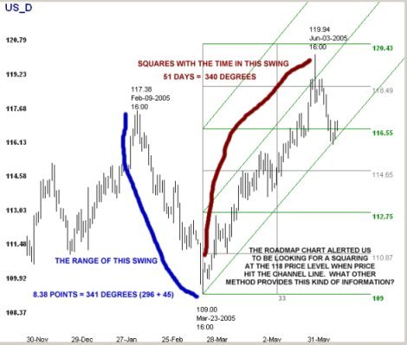
There is nothing else to buy. You do not need an expensive Gann Wheel, or overlays, or compasses or anything else that gets sold in the usual Gann course. We show you step-by-step exactly how to determine with a simple mathematical formula when price and time square for any ticker in any time frame. Unless you're really good with square roots you will need a cheap calculator. To accelerate your learning speed we are making a beta version of the training software to draw the Roadmap Charts available at no cost to current and past purchasers of this ebook.
Using the Look-Ahead feature of this mathematical application of the Square of Nine, you could have determined to watch for a change in Crude's bullish trend less than 1 point from a major high.
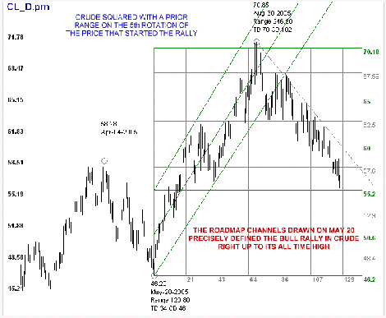
So far as we know the totality of information in this ebook is not available from any other single source at any price. Included as appendices are excerpts from WD Gann's original works: "Why Geometrical Angles Work on Stocks," "The Master Mathematical Price, Time and Trend Calculator" and others.
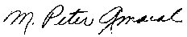
TRADINGFIVES
June 2, 2003
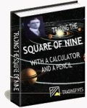 | The price of this ebook is $34.00. This ebook is in Adobe Acrobat (PDF) format. Adobe Reader is required and may be downloaded for free at www.adobe.com. This ebook is 58 pages, single space, 11 point Arial type with charts and illustrations.  If you are not 100% satisfied, just let me know within 90 days for a full refund. And keep the e-book free, with my compliments - that way, you risk nothing. If you have any other questions or concerns about the material you can call Peter at (561) 654-4129.

SQUARE OF NINE PRINCIPLES AT WORK

GANN ANGLES WITHOUT TRYING?
W.D. Gann used geometric angles drawn from pivot highs and lows to visualize how the market was balancing price and time. The most important angle, Gann said, was the 1x1 angle which was allegedly set at 45 degrees. Many so-called Gann analysts believe 1x1 means one point in price per one day of trading. Fast markets moved at 2x1 which allegedly meant two points of price per one day of trading. You can still buy "special" Gann charting paper (that must be woven with gold) if you believe that. What happens when you want to see a 1x1 angle on the Dow which is trading at 10,000? One point a day for 10,000 days doesn't cut it.
I suppose you could try all kinds of different price conversions or slope calculations for different grid sizes but good luck when you want to accomodate different computer screens. You can try that too, but you're looking for things only where the light is shining the brightest. W.D. Gann used geometric angles alright, but they had nothing to do with grid or paper size. Gann angles are based on the geometry of the circle. 360 degrees. When we started experimenting with our mathematical application of the Square of Nine we were not looking for a way to draw Gann Angles, 1x1 or any other kind, but that may have been the result. Even if we weren't trying.

WHY IS A ROADMAP CHART CHANNEL DIFFERENT FROM A TRENDLINE?
The Roadmap grid is drawn immediately after a suspected pivot point occurs in the time frame in which you are trading. When you draw a Roadmap grid you are not channeling a price pattern. The prices haven't happened yet! The dimensions of the grid are fixed (by you) and remain constant for the duration of the new trend. If, indeed, the suspected pivot point is a change in trend, prices will often remain entirely within the diagonal grid channels for the life of the new trend. Possibly for months or years (see Weekly SPX Roadmap below).

HOW DO YOU KNOW WHAT GRID SIZE TO USE?
How do you determine the dimensions of the grid? Every ticker has its own natural vibration, usually based on a 90 degree or 60 degree set of Square of Nine angles. We use 90 degree proportions for our SPX grid. W.D. Gann said more than sixty years ago that 90 degrees was the natural vibration of the US stock market, and despite the profound economic and social changes that have occurred since then he's still right. Some traders prefer a 60 degree set for US Bonds and some commodities. We have made it easy to experiment by including, upon request, a beta version of the Square of Nine utility program (screenshot) we use to draw these charts to all current and past buyers of our Square of Nine book.
Although we believe that the Roadmap Charts are a valuable trading tool in their own right they only tell a small part of the story. The grid is based entirely on Square of Nine principles and the horizontal grid lines do show proper aspects of the starting price, but the Roadmap Charts do not tell you where and when price and time have squared or will square in the future. That requires some uncomplicated but necessary calculations. We show you how to do that in our book.

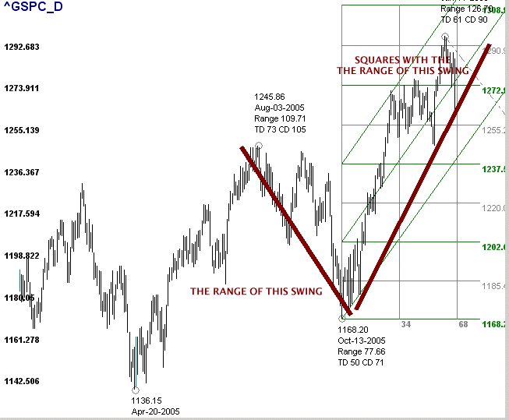
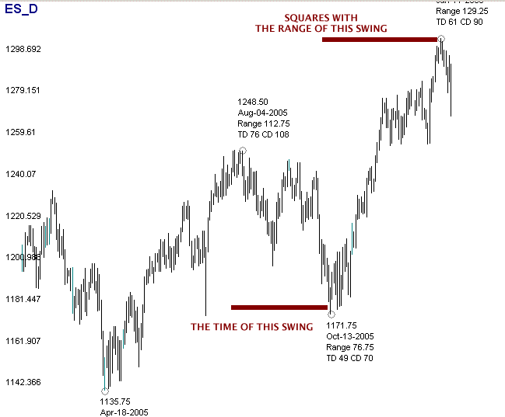
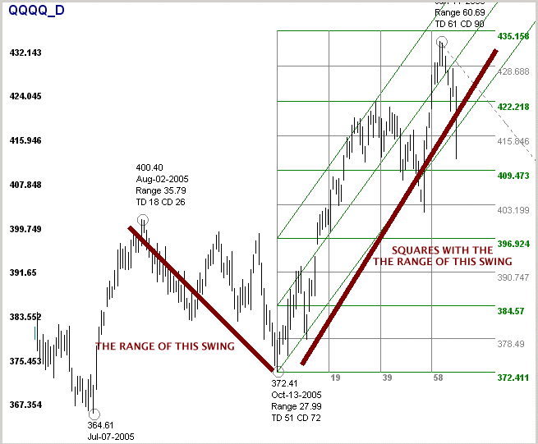
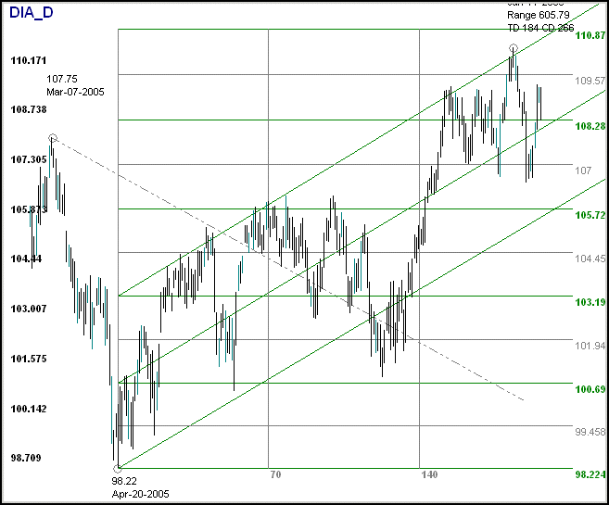
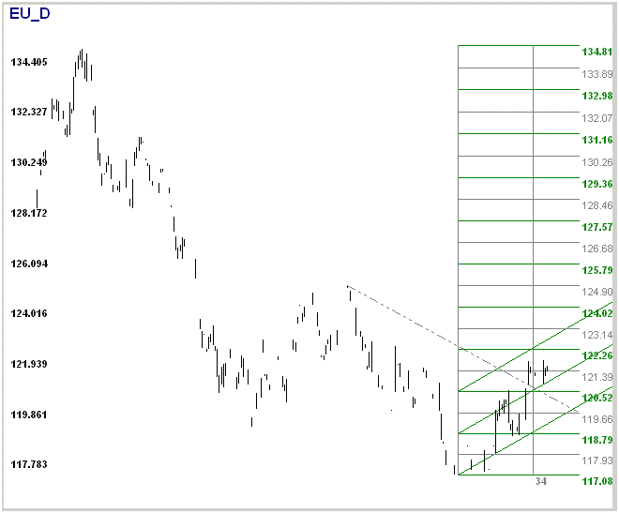
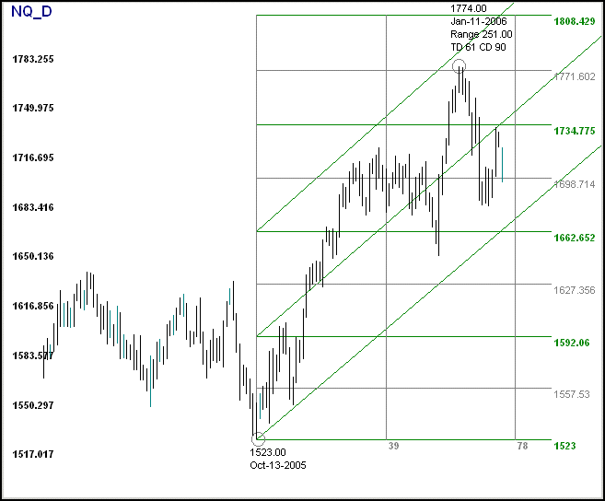
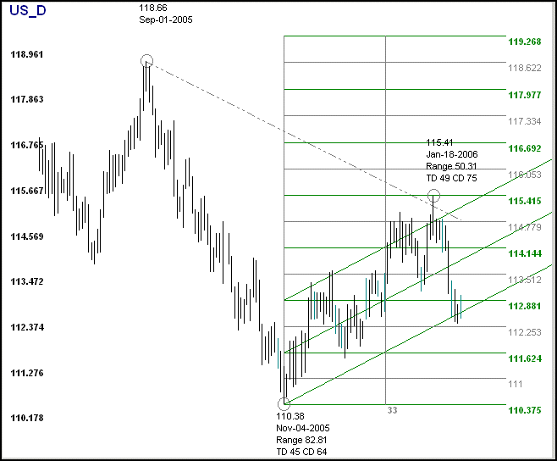
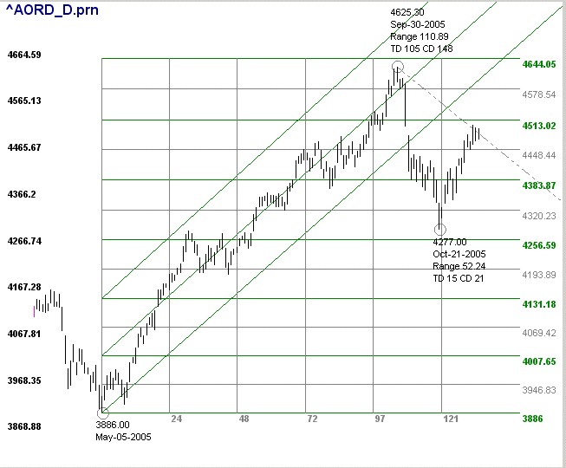
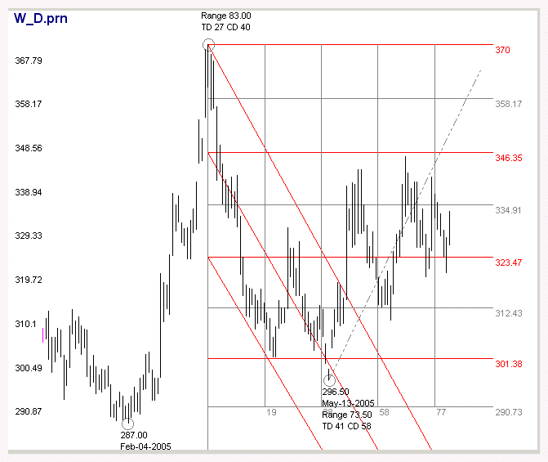
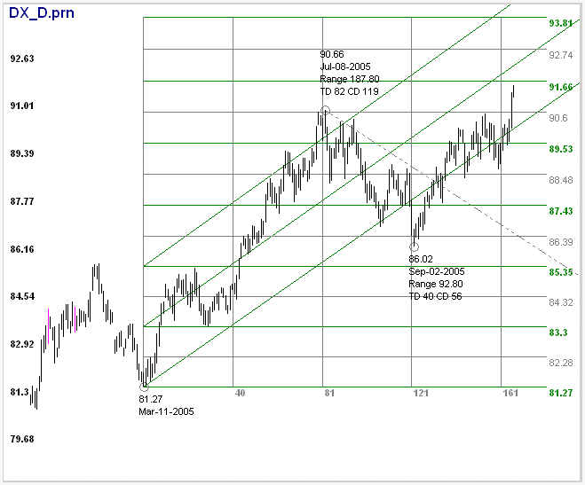
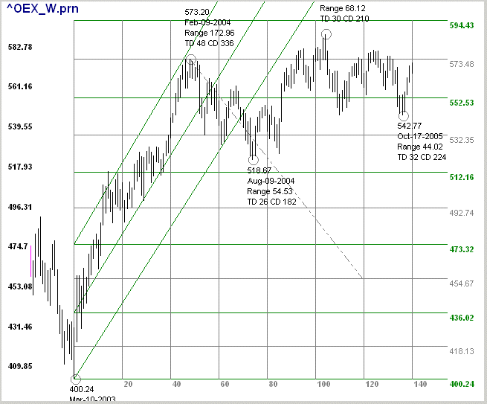
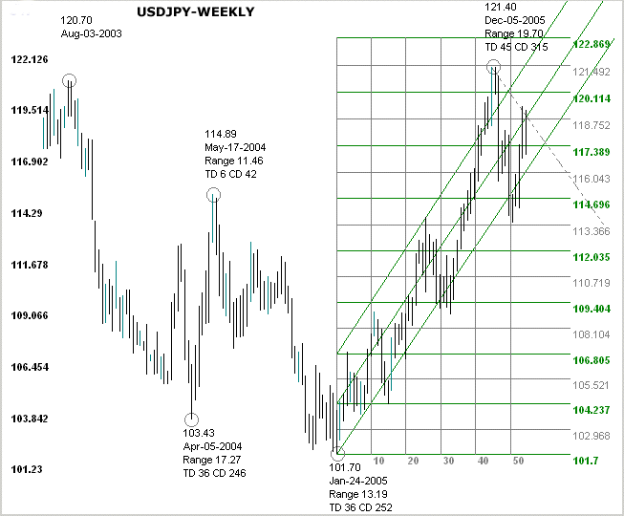
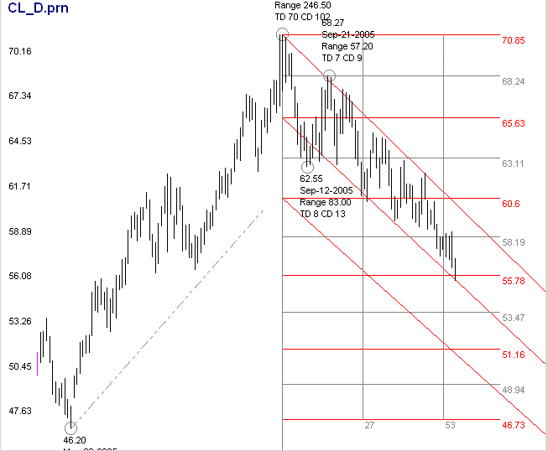
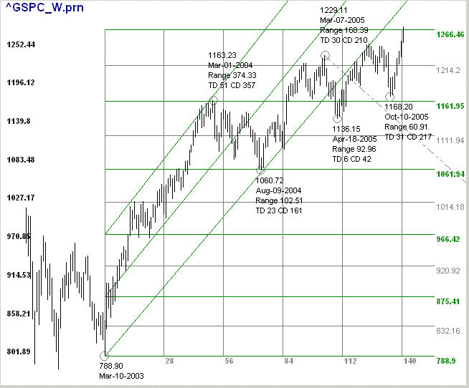

SQUARE ROOT THEORY
References to the Square Root Theory as a predictor of stock prices pops up every now and then in financial writings. Norman Fosback used the theory in a 1976 publication called Stock Market Logic to make the case that the normal trading range of low price stocks provides greater profit opportunities than the normal trading range of high price stocks. In 1983, a book entitled The Templeton Touch, by William Proctor, disclosed that one of Templeton's 22 principles for stock market investing was that stock price fluctuations are proportional to the square root of the price.
In the 1950s William Dunnigan developed two stock trading systems called the Thrust Method and the One Way Formula. Both methods had several advantageous entry techniques but each lacked an effective exit technique. Dunnigan was above all a portfolio manager and not happy with the risk-reward aspects of his own trading methods, Dunnigan supported and publicized the Square Root Theory. He went so far as to call this theory the "golden key" and claimed recognition from some economics and statistical trade journals of the era.

WHAT IS THE SQUARE ROOT THEORY?
The theory holds that stock and other publicly traded instrument prices move over the long and short term in a square root relationship to prior highs and lows. For example, IBM made a monthly closing low of 4.52 in June, 1962 and monthly closing high of 125.69 in July, 1999. This is within a few percentage points of the square of the sum of the square root of the low price + 9 or (2.12+9)^2. GM made a low of 15 in November, 1974 and a high of 95 in May, 1999. Again, a few percentage points from the square of the sum of the square root of the low + 6 or (3.87+6)^2. There are hundreds of these examples across the stock, financial and commodity markets. Even a few minutes with a pile of stock charts and a calculator will build confidence that major highs and lows are related to each other by additions and subtractions to their square roots.

SQUARE ROOT THEORY IN ACTION
Let’s go through a recent daily chart of the SP500 and see how it works. The SP500 made a pivot low at 1060.72 on Aug-13-2004. Is there a square root relationship to that low that may be predictive of a future pivot high? Are other high and low pivots related by square roots?
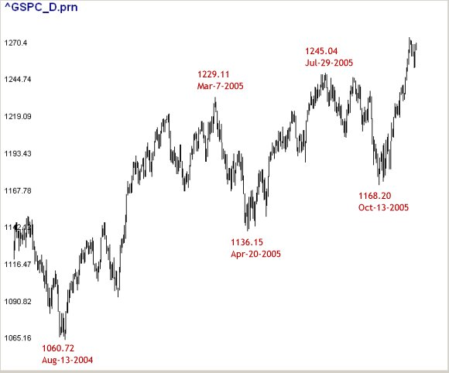
Let's do the math. You can refer to the tutorial on constructing a Roadmap Chart in Excel for more detail.
- Aug-13-2004 low = 1060.72 = Square Root 32.568
32.568 + 2.5 = 35.068
35.068 ^2 = 1229.81 = Mar-7-2005 high!
- Mar-7-2005 high = 1229.11 = Square Root 35.058
35.058 - 1.25 = 33.808
33.808 ^2 = 1143.03 = Apr-20-2005 low!
- Apr-20-2005 low = 1136.15 = Square Root 33.706
33.706 + 1.25 = 35.207
35.207 ^2 = 1239.52 = Jul-29-2005 high!
- Jul-29-2005 high = 1245.04 = Square Root 35.285
35.285 - 1 = 34.285
34.285 ^2 = 1175.46 = Oct-13-2005 low!
How did we know to use 1 or 1.25 or 2.5 to add or subtract from the pivot points? Gann said that 90 degrees is very important for the markets. Gann also said that the number 2 represents a full circle or 360 degrees. 1 therefore equals 180 degrees and .500 and 250 90 degrees and 45 degrees respectively. We only had to add or subtract a few increments of .500 or .250 to each pivot point to obtain these results. Longer swings or high priced indexes may require 3, 4, 5 or even higher base addends or subtrands.
Before Dunnigan and Templeton, probably starting in the early 1900s, W.D. Gann was using square roots as an integral part of his method to forecast stock and commodities prices and times. His method was more complex than what you see here. It appears to have been based on some ideas Gann picked up during his trips to India or Egypt. Gann used an ennegram, a diagram of numbers constructed in such a way to show square and square root relationships. This ennegram is what’s come to be known as the Square of Nine from the Greek root “enneas” which is the word for “nine.”
Although Gann never revealed exactly how he used the ennegram we can gather from his words that it was probably very important to him: "We use the square of odd and even numbers to get not only the proof of market movements, but the cause." W. D. Gann, "The Basis of My Forecasting Method" (the Geometrical Angles course), p. 1

The Morning Telegraph
Sunday, December 17, 1922
Wall Street Scientist Forecasted Top of Bull Market 1-Year in Advance.
HIS INDICATIONS UNCANNY
by: ARTHUR ANGY
(Financial Editor, The North Side News)
W.D. Gann has scored another astounding hit in his 1922 stock forecast issued in December 1921. The forecast called for first top of the bull wave in April, second top in August, and the final top and culmination of the bull market October 8 to 15, and strange as it may seem, the average prices of twenty industrial stocks reached the highest point on October 14 and declined 10 points in thirty-days after that date.
Mr. Gann predicted a big decline for the month of November. He said in the 1922 forecast - "November 10-14 panicky break." During this period stocks suffered a sever decline, many falling 10 points or more in four days and on November 14 lowest average prices were made with 1,500,00 shares traded in on the New York Stock Exchange.
I found his 1921 forecast so remarkable that I secured a copy of his 1922 stock forecast in order to prove his claims for myself. And now, at the closing of the current year in 1922, it is but justice to say I am more than amazed by the result of Mr. Gann's remarkable predictions based on pure science and mathematical calculations.
The North Side News stands for a clean Wall Street and has rendered a great public service in helping to rid Wall Street of the bucket shop evil by publishing a series of articles in conjunction with the Magazine of Wall Street. We believe in banding a fake, and we believe in giving credit where due.
GANN IS NO TIPSTER
W. D. Gann is no "Wall Street tipster" sending out market letters and so-called-inside information - Mr. Gann's results are obtained by profound study of supply and demand, a mathematical chart of money, business and commodities. He determines when certain cycles are due, and the order and the time when market movements will follow.
During the past thirty years many men have proclaimed discoveries and theories to "beat the Wall Street game," most of which resulted in loss to their followers. They could always tell by the chart just why the market did it after it happened. Mr. Gann's theory differs from the others in that he tells months in advance what stocks are going to do.
His forecast stated that some stocks would make high this year in April, some in August and others in October - the month when he predicted the bull movement would culminate. Of a list of a hundred stocks; thirty made highest price in April and many declined, while others continued higher, twenty made high during August, and fifty made high of the year in October. from which the largest decline of the year has taken place.
His 1922 forecast indicated final tops on railroad stocks for August 14. The Dow Jones's averages on rails made high August 21 and reached the same average levels on September 11 and October 16, but did not exceed the high made in August, which was made seven days later than the exact date called for in the forecast.
HIS CHART IS A FACT
Stock Market accurate long-range forecasting, as W. D. Gann is doing, sounds almost unbelievable, and how he does it I do not know, but the writer does know that he does it. My attention was first called to his 1921 Market Forecast, in which he predicted stocks would be bottom in August, 1921, and advance to December, 1921. They did so. His chart or graph of the market one year in advance is a fact, and that the course of the stock market follows it astoundingly close is equally a fact.
Mr. W. D. Gann says the trouble with most chart makers is that they work with only one factor - space movements or charts which record one to two points up or down - whereas there are three or more factors to be considered, space, volume and time. The most vital is time, and back of that is the cause of recurrence of high or low prices at certain intervals.
I asked Mr. Gann: "What is the cause behind the time factor?"
He smiled and said: "It has taken me twenty years of exhaustive study to learn the cause that produces effects according to time. That is my secret and too valuable to be spread broadcast. Besides, the public is not yet ready for it."
"Water seeks its level," continued Mr. Gann. "You can force it higher with a pump, but when you stop pumping it requires no force to cause it to return to its former level. Stocks and Commodities are the same. They can be forced above their natural level of values to where lambs lose all fear, become charged with hope and buy at the top. Then stocks are permitted to sink to a level where hope gives way to despair and the most rampant bull becomes a bear and sells out at a loss. My discover of the time-factor enables me to tell in advance when these extremes must, by the law of supply and demand, occur in stocks and commodities."
(The Morning Telegraph, Sunday, December 17, 1922)

HOW TO CONTRUCT A SQUARE OF NINE
ROADMAP CHART IN EXCEL
This tutorial will show you how to construct a Square of Nine Roadmap Chart from a regular price chart created in Excel You could also use a chart printed out from Yahoo or Big Charts or any other online service or charting program. This example uses Hourly Data (65 minutes actually) of the S&P 500. Hourly charts are good to practice with because conditions change quickly and you get many opportunities to experiment. We will assume that you already know how to create a stock chart in Excel. This is what the plain-jane stock chart looks like. We used high-low-close bars but if the chart doesn't get too crowded candles also work nicely.
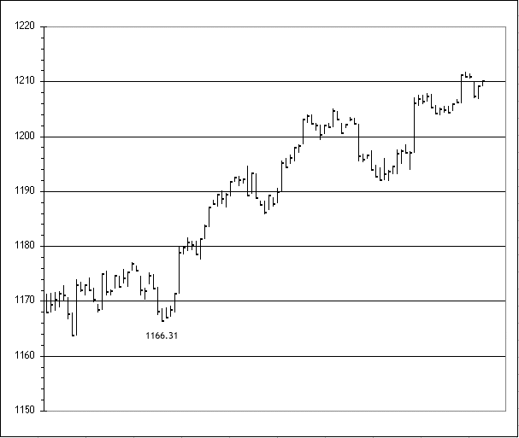
When you scroll around on your Excel chart while working in the program itself, the value of the data point under the mouse cursor will appear in a little window. In this case we want to start the Roadmap from the low at 1166.31, which occurred on January 28, 2005 at the 11:40 bar.
From the Square Root Theory you learned that we can move 360 degrees around the Square of Nine by adding 2 to the square root of a number and squaring the resulting sum. In the example on the Roadmap Theory page we moved from 15 to 34, which is directly above 15 on the Square of Nine, by taking the square root of 15 (3.87), adding 2 (5.87) and squaring that sum (34.49). A paper version of the Square of Nine uses rounded numbers and 34.49 was rounded down to 34. Just so we have some common language to work with we call the "2" we added to the square root of 15 a Factor of 2. We understand that Factor is a mathematical term of art, and in that sense it's being misused, but most people reading this are not mathematicians and will not be greatly offended.
If a Factor of 2 represents 360 degrees or a full circle move, then 45 degrees or 1/8 circle will be represented by a Factor of .25 (360/8 = 45) and (2/8 = .25). Many, if not most, major stock market moves end on a multiple of 90 degrees. We're working with Hourly data and because 90 degrees may be too granular we use 45 degrees which is an exact division of 90 degrees for our Hourly Roadmap Charts. If you want to work with Daily or Weekly data then we suggest using 90 or 180 degree Factors, which are .5 and 1 respectively, (360/4 = 90 and 2/4 = .5) and (360/2 = 180 and 2/2 = 1). In practice, you can use any Factor you want and odds are that at least one will fit your trending data points exactly, even though it would have allowed you to draw the Roadmap Chart before the fact. Gann said that 90 degrees is very important for the stock market, and our own experience with the major stock market indexes confirms that, but there very well could be other very important factors for different stock market indexes, currencies, commodities or individual stocks. There is probably much more that remains unknown and undiscovered about the application of the Square of Nine than we can imagine, so experimentation is encouraged for those willing to do the work.
Now that we've decided to use a Factor of .250 (representing 45 degrees) we can begin to actually construct the chart. We'll use our starting point, the low at 1166.31, to calculate price levels for the horizontal lines. Here's the math:
(SQRT(1166.31) + .250) ^2 = 1183.45
(SQRT(1166.31) + .500) ^2 = 1200.71
(SQRT(1166.31) + .750) ^2 = 1218.10
Eyeball these price levels on your Excel chart and draw in a horizontal line at each price level. The chart will look like this.
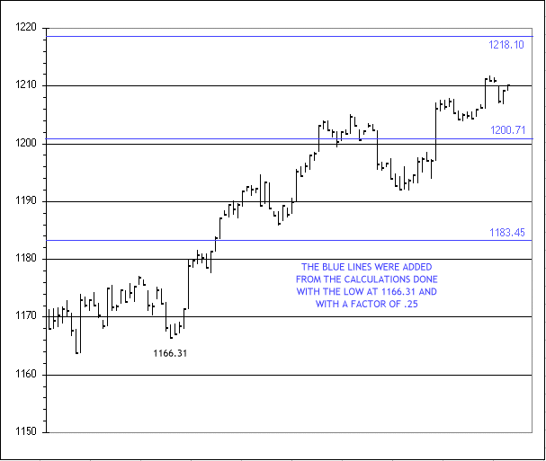
Let's add the vertical time lines. Use the same low price of 1166.31. Find the square root (34.15) and round it to the next whole number (34). To complete the vertical time lines all that must be done is draw the lines in 34 bar increments from the starting point of the bar at 1166.31. Draw as many vertical time lines as will fit on the chart. The chart will look like this.
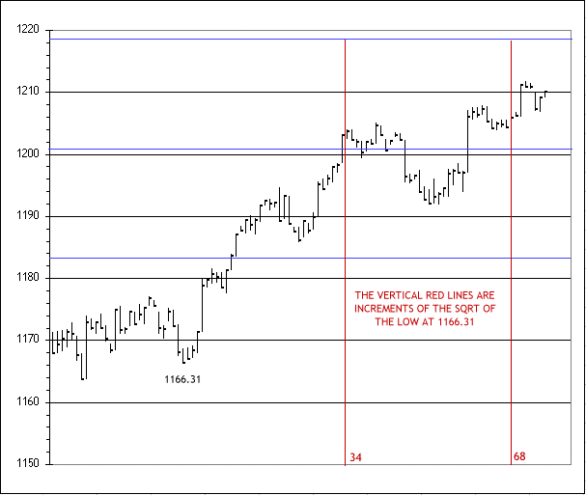
You're almost there. Add one more vertical line at the starting point price bar at the low of 1166.31 and draw diagonal lines through the intersections of the horizontal and vertical lines. The chart-in-progress will show you graphically what and where to connect things better then any verbal description.
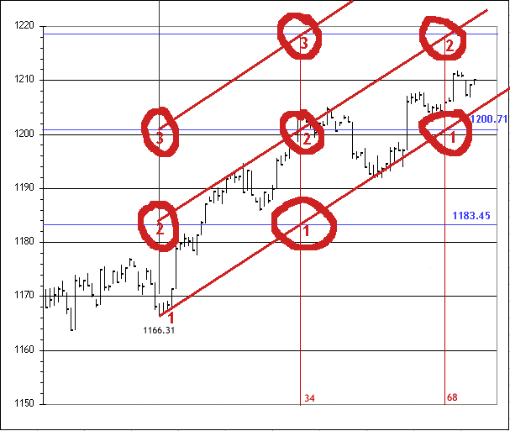
That's all there is to it! You've created a Roadmap Chart. Once you get a feel for the rhythm of the tickers you trade the most, and the Factor that best represents that rhythm, you can create a new Roadmap Chart within minutes of a suspected pivot point. The Roadmap Chart is self-defining. If the trend has changed then the new Roadmap Chart will contain the future price bars for the life of the trend. If the suspected pivot point bombs-out you will know immediately when price bars bust the channels.
One obvious thing we did not mention is that if you're drawing a new Roadmap from a high then you would subtract, not add, the Factor from the square root of the starting price. The vertical line, time calculation, would be the same. Depending on the quote price of your ticker you may get weird results in your early attempts to create a new chart. You will have to experiment, but generally, you want to convert prices into three significant digits (i.e three numbers to the left of the decimal point) to get proportional results. Use a multiple of 10 (multiply or divide by 1/10, 10, 100, 1000, etc.) to convert your prices to three significant digits before calculating the price levels of the horizontal lines. You do not have to change the price scale of the chart, only the price to use when calculating the horizontal price lines. We use natural S&P prices, which currently are four significant digits, for our charts and everything works just fine so like most everything else about the Square of Nine there are no absolutes, and the value you receive is directionally proportional to the effort you make..
We think the Roadmap Chart is a great trading tool without learning another thing about the Square of Nine. How many tools allow you to define a trend ahead of time? Ideally, price will move across the width of the channels before ending the trend. Reactions that do not end the trend often occur near the midpoint of the time lines or the midpoint of the major horizontal price lines. There's no substitute for experience in learning the natural rhythm of your tickers and how to use the Roadmap Charts to your advantage. Although the Roadmap Chart is based on Square of Nine principles, and as elegant as we believe the Roadmap Chart to be, it does not square price and time. To do that you must first convert both price and time to degrees of a circle and measure them from defined starting points. The Roadmap Chart does not do that.

The Gann Studies
by Justin Kuepper,
Predicting the future is impossible, right? If he were around today, W.D. Gann would beg to differ. His first prophecy is believed to have happened during World War I when he predicted the Nov 9, 1918, abdication of the Kaiser and the end of the war. Then in 1927, he wrote a book entitled "Tunnel through the Air", which many believe predicted the Japanese attack on Pearl Harbor, and the air war between the two countries.
His financial predictions were perhaps even more profound. In early 1929, he predicted that the markets would probably continue to rally on speculation and hit new highs… until early April. In his publication, The Supply and Demand Letter, he delivered daily financial forecasts focusing on both the stock and commodity markets. As this daily financial publication gained notoriety, Gann published several books - most notably "Truth", which was hailed by the Wall Street Journal as his best work. Finally, he began releasing the techniques that he used to make these forecasts: the Gann studies.
What Are the Gann Studies?
In 1908, Gann discovered what he called the "market time factor", which made him one of the pioneers of technical analysis. To test his new strategy, he opened one account with $300 and one with $150. It turned out to be wildly successful: Gann was able to make $25,000 profit with his $300 account in only three months; meanwhile, he made $12,000 profit with his $150 account in only 30 days! After his results were verified, he became famous on Wall Street as one of the best forecasters of all time.
Here's how his techniques work. Gann based predictions of price movements on three premises:
- Price, time and range are the only three factors to consider.
- The markets are cyclical in nature.
- The markets are geometric in design and in function.
Based on these three premises, Gann's strategies revolved around three general areas of prediction:
- Price study– This uses support and resistance lines, pivot points and angles.
- Time study – This looks at historically reoccurring dates, derived by natural and social means.
- Pattern study – This looks at market swings using trendlines and reversal patterns.

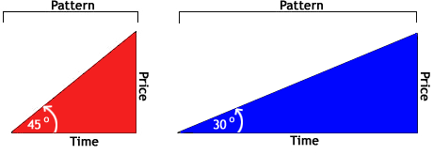

Figures such as these are the building blocks of the Gann studies.

Constructing Gann Angles
Before we begin, it is important to realize that this form of analysis - like most forms of technical analysis - is not set in stone but constructed out of empirical methods. Without further ado, here is the process used to construct a Gann angle:
- Determine the time units - This is one of the empirical processes. One common way to determine a time unit is to study the stock's chart and take note of distances in which price movements occur. Then, simply put the angles to the test and determine their accuracy. Most people use intermediate-term (such as one to three-month) charts for this as opposed to long-term (multi-year) or short-term (one to seven-day) charts. This is because, in most cases, the intermediate-term charts produce the optimal amount of patterns.
- Determine the high or low from which to draw the Gann lines - This is the second empirical process, and the most common way to accomplish it is to use other forms of technical analysis--such as Fibonacci levels or pivot points. Gann himself, however, used what he called "vibrations" or "price swings." He determined these by analyzing charts using mathematical theories like Fibonacci.
- Determine which pattern to use - The two most common patterns are the 1x1 (left figure above), the 1x2 (right figure above), and the 2x1. These are simply variations in the slope of the line. For example, the 1x2 is half the slope of the 1x1. The numbers simply refer to the number of units.
- Draw the patterns - The direction would be either downward and to the right from a high point, or upward and to the right from a low point.
- Look for repeat patterns further down the chart – Remember this technique is based on the premise that markets are cyclical.
Again, this requires some fine-tuning with experience in order to perfect. Because of this, the results will vary from person to person. Some people, like Gann, will experience extraordinary success, while others - who don't use such refined techniques - will experience sub-par returns. However, if the system is followed and sufficient research is put into finding the optimal requirements, above-average returns should be attainable. But remember, technical analysis is an odds game -add more technical indicators to increase your chances of a successful trade.
Using Gann Angles
Gann angles are most commonly used as support and resistance lines. But many studies have support and resistance lines. What makes this one so important? Well, Gann angles let you add a new dimension to these important levels - they can be diagonal.
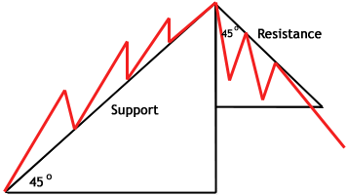
Here you can see how Gann angles can be used to form support and resistance levels. Diagonal trendlines are commonly used to determine times to add to existing long positions, to determine new lows and highs (by finding significant breaks of the trend line), and to help discern the overall trend.
Conclusion
Is it possible to predict the future? W.D. Gann probably thought so, and seemingly proved it with his wildly successful returns. The system is relatively simple to use, but difficult to master. After all, it was Gann's uncanny ability to fine-tune his techniques that led him to enormous profits - the average investor is not likely to obtain these kinds of returns. Like many technical tools, Gann angles are best used in conjunction with other tools to predict price movements and profit.

Pivot Point

What Does Pivot Point Mean?
A technical indicator derived by calculating the numerical average of a particular stock's high, low and closing prices.

Investopedia explains Pivot Point...
The pivot point is used as a predictive indicator. If the following day's market price falls below the pivot point, it may be used as a new resistance level. Conversely, if the market price rises above the pivot point, it may act as the new support level.

Gann Angles

What Does Gann Angles Mean?
Created by W.D. Gann, a method of predicting price movements through the relation of geometric angles in charts depicting time and price.

Investopedia explains Gann Angles...
The ideal balance between time and price exists when prices move identically to time, which occurs when the Gann angle is at 45 degrees. In total, there are nine different Gann angles that are important for identifying trend lines and market actions. When one of these trend lines is broken, the following angle will provide support or resistance.

Support (Support Level)
What Does Support (Support Level) Mean?
The price level which, historically, a stock has had difficulty falling below. It is thought of as the level at which a lot of buyers tend to enter the stock.
Often referred to as the "support level".
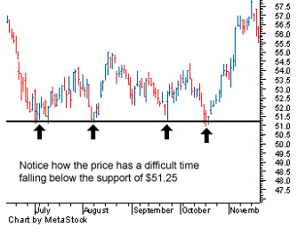

Investopedia explains Support (Support Level)...
If the price of a stock falls towards a support level it is a test for the stock: the support will either be reconfirmed or wiped out. It will be reconfirmed if a lot of buyers move into the stock, causing it to rise and move away from the support level. It will be wiped out if buyers will not enter the stock and the stock falls below the support.

Trendline
What Does Trendline Mean?
A line that is drawn over pivot highs or under pivot lows to show the prevailing direction of price. Trendlines are a visual representation of support and resistance in any time frame.

Investopedia explains Trendline...
Trendlines are used to show direction and speed of price. Trendlines also describe patterns during periods of price contraction.

W. D. Gann
the legendary Financial Prophet in the Early Twenties
To most of the technical analysts and financial traders, the name, William Delbert Gann, is well-known. Gann was one of the greatest traders in the early twenty centuries, who has extremely arcane trading analysis techniques and methods that based on ancient mathematics, geometry and astrology. Yet, as it was never unveiled explicitly, the theory of Gann is admired by most, but grasped by few.
To understand Gann's theories, it is essential to know his life and living.
W. D. Gann was born in an Irish family in Lufkin, Texas in the United States on 6 June 1878. His parents are devoted Christians with a strong Methodist background. W. D. Gann was himself a devoted Christian. He claimed that his market cycle theories were discovered from the Holy Bible.
The home country of Gann was a cotton land, the influence to the childhood of the great trader was understandable. With Gann was 24 in 1902, he made his first trade in cotton futures contract and enjoyed the profit from trading. The 53 years of trading hereafter, it was said that he had gained US$50 million from the market. The wealth of that scale compared with the purchasing power at his time was, in deed, very substantial.
In 1906, Gann moved to Ohakama with ambition to start up his career as broker and trader. His life and trading are with up and down. His advice after decades of trading were that if an investor enters the investment market without a grasp of knowledge, his chance to failure would be 90%. The reasons behind their failures are human emotions: hope, greed and fear are the enemies of success.
Knowledge is the way to win in the market. Starting from his early age, Gann had already realized that the natural law is the underlying driving force that moves the market. He claimed that he had spent 10 years in studying the relationship between natural law and the market. During these 10 years, he had traveled to England, Egypt and India for knowledge. When he was in England, he spent days and nights in the British Museum to study the financial markets for over a hundred years. During that time, he focused himself on ancient mathematics, geometry and astrology for inspiration and revealed their relationships with the financial markets. One of his important techniques, the Gann Cardinal Square, was said to be inspired from the structure of Egyptian and Indian temples.
After the long journey for knowledge, he concluded his findings that the financial markets are driven by the "Law of Vibration". The law once grasped, one can tell the future market time and price with high accuracy. Gann also claimed that the "Rate of Vibration" of individual stocks and futures contracts determine the up and down of their prices.
Unfortunately, the details of his theory are often kept in veil. Late comers are very difficult to grasp the essence of his techniques. In general, his theories are based on the followings: ancient mathematics, geometry, numerology and astrology.
In 1908, Gann moved to New York at the age of 30, where he started his brokerage and research business and serious tested his theories and trading techniques. In the same year, he developed his major technique "Master Time Factor" with success that made him famous on the Wall Street.
In October 1909, he was interviewed by Richard D. Wyckoff of the Ticker and Investment Digest, a then popular financial magazine in early twenties. The interview extended for a usual period of one month in order for the reporter to monitor his trading activities.
To the surprise of the reporter, Gann stroked a return of 1000% on his trading capital. He had made a total of 286 trades in 25 market days, 264 times won and 22 times lost. The profit rate was up to 92.3%. During that month, the average interval between trades was only 20 minutes. On one trading day, he made totally 16 trades, 8 out of them are the reversal points of the intra-day market fluctuation.
According to Gann's friend William Gilley, "One of the most astonishing calculations made by Mr. Gann was during last summer [1909] when he predicted that September Wheat would sell at $1.20. This meant that it must touch that figure before the end of the month of September. At twelve o'clock, Chicago time, on September 30th (the last day) the option was selling below $1.08, and it looked as though his prediction would not be fulfilled. Mr. Gann said, 'If it does not touch $1.20 by the close of the market it will prove that there is something wrong with my whole method of calculation. I do not care what the price is now, it must go there.' It is common history that September Wheat surprised the whole country by selling at $1.20 and no higher in the very last hour of trading, closing at that figure."
At the peak of his career, Gann founded two market research companies, W. D. Gann Scientific Service, Inc. and W. D. Gann Research Inc., and employed 35 people to produce technical charts and conduct market research. He published investment newsletters and made annual stock and commodity forecasts that attracted much attention from the investment community. Gann also hosted several investment and trading seminars. Gann tried to make his teaching secret and confined to a few people, every student is not allowed to give the materials out to others. The fees for these seminars were US$2500 and sometimes US$5000, which enormous at his time. It may be equivalent to US$25,000 to US$50,000 nowadays!
His Methods
According to his followers, the accuracy of W. D. Gann's prediction was up to 85%. His predictions actually were not restricted to financial market; Gann also gave predictions on the election of US President and the beginning and ending of World Wars. Gann claimed that his every forecast was solely based on mathematical principles. With sufficient information, he could forecast the forthcoming events with his cycle theory based on ancient mathematics and geometry. In his mind, the nature of things had not changed; all of the events were based on mathematical principles.
What are the mathematical principles?
W. D. Gann said that the 360 degrees of a circle and the numbers from 1 to 9 were the origin of mathematics. In a circle, there may place a square and a triangle. Outside the circle, we may also construct a square and a triangle. These constructions are in fact the dimensions of the market.
Strange enough? In fact, W. D. Gann believed that the market reversal points (tops and bottoms) were related by the mathematical principles. There is no single market top or bottom cannot be explained by angles and support / resistance levels. In other words, if he was given the time and prices of the historical tops and bottoms of any market, he could utilize the mathematical and geometrical principles to predict futures market turning points. Why were these principles able to be applied to the market trends? W. D. Gann said that he had every proof from astrology and mathematics!
His Market Predictions
Interesting enough, W. D. Gann lived in the early Twenty Centuries while the economic life of the world was in total chaos. Gann experienced the first World War, the historic stock market crash in 1929, the great depression in the Thirties and the out-break of the World War II. In these years of frustration, conducting investment business was risky, not to mention market predictions.
Since the Twenties, W. D. Gann began to publish annual market forecast reports. These reports provided market forecasts for the whole year to come. It was nothing new by providing these types of service. The new things were that W. D. Gann actually depicted the market movement of the whole year by providing detailed time and prices of the market reversal points! His annual forecasts were in fact the road maps to wealth. He did not only forecast the market, he also provided forecasts of major social events. Although, his predictions might not be totally correct, his approach turned a new leaf in market forecasting.
Surprisingly, he accurately predicted the stock market crash of the century in 1929 to the date. In his annual forecast published on November 3, 1928, he explicitly predicted that September of 1929 would be the dangerous month. Stock prices would slump on "Black Friday". In fact, the Dow Jones Industrial Average toped out on September 3, 1929 at 386.10. Two months later, the Dow fell to below 200! The bear market brought to the western world the great depression and the Dow eventually bottomed out at only 40.56 in July 1932.
W. D. Gann's Writings
W. D. Gann passed away at 77 on June 14, 1955. He had numerous writings including:
"W. D. Gann Stock Market Course"
"W. D. Gann Commodity Market Course"
"The Truth of the Stock Tape"
"Wall Street Stock Selector"
"Stock Trend Detector"
"45 Years in Wall Street"
"How to Make Profits Trading in Commodities"
"How to Make Profits Trading in Puts and Calls"
"Tunnel Thru' the Air"
"The Magic Words"
Most of his writings are related to investment and trading. "Tunnel Thru' the Air" is however a love story. Gann claimed that the first time you read, it would be a book of love story. The second time you read, it would be a book of parables. The third time you read, it would be a book of market truths!
The "Magic Words" is a book of religious writings.
(Copyright Reserved 1999)
Methods and Applications of Gann Square

Gann Price Square
Cardinal Square is W.D. Gann's method to calculate market support and resistance levels. With base number 1 at the centre of the square, Cardinal Square starts from the left or right hand side and expands in clockwise or anti-clockwise fashion, each step increases the number by 1 and eventually comes with a Cardinal Square. The chart below is W. D. Gann's Square of Nine.
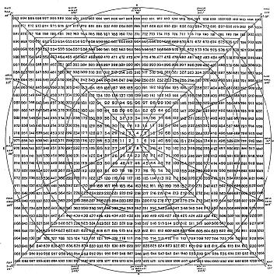
The support and resistance levels of the market in question are on the following angles in Price Cardinal Square. They are primarily:
- The horizontal line that drawn through the centre of Cardinal Square;
- The vertical line that drawn through the centre of Cardinal Square; and
- The two diagonal angles that drawn through the centre of Cardinal Square.
When we use the Cardinal Square to predict specific market support and resistance levels, two inputs have to be decided:
Firstly, the starting point of the market trend to be put into the centre of the Gann Square; and
Secondly, the unit of increase or decrease in each step.
The Gann Square function in the Gann Forecaster software provides easy calculation of the Gann Square.
Chart 1 Cardinal Price Square
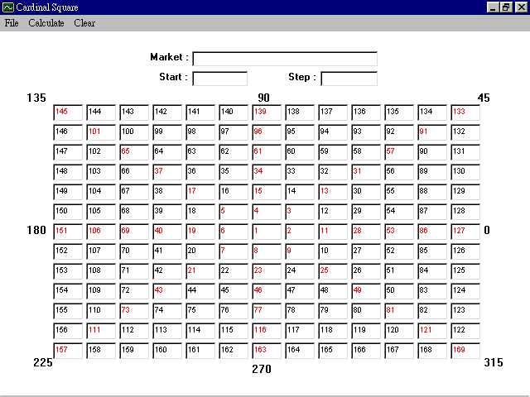

Working Example:

Suppose we are going to calculate the support and resistance of Hang Seng Index. The intermediate low of Hang Seng Index was 6,890 on 23 January, 1995. Using this data, we input the following:
- Market : Hang Seng Index
- Start : 6890
- Steps: +100

After the input, all figures in the Cardinal Square shall be changed to relevant price levels. The support and resistance levels of the market should be shown in RED colour, which are numbers on 45, 90, 135, 180, 225, 270, 315 and 360 degrees on the Square. The following diagram shows the results of the calculation:

Chart 2 Cardinal Price Square with Hang Seng Index
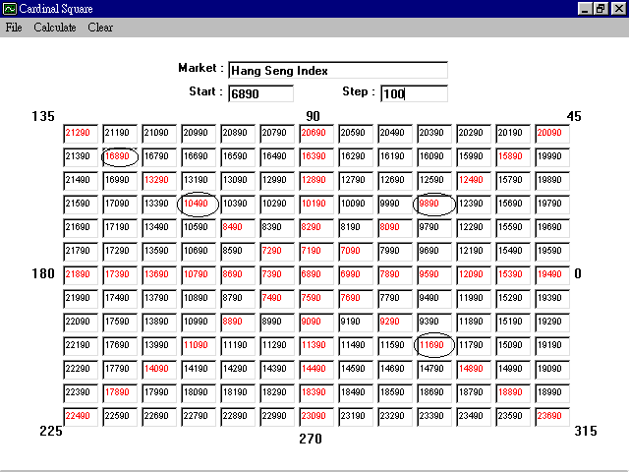

The circled numbers are major resistance levels in Hang Seng Index. The corresponding daily chart of Hang Seng Index is shown below:

Chart 3 Resistance Levels on Hang Seng Index Daily Chart (93 - 97)
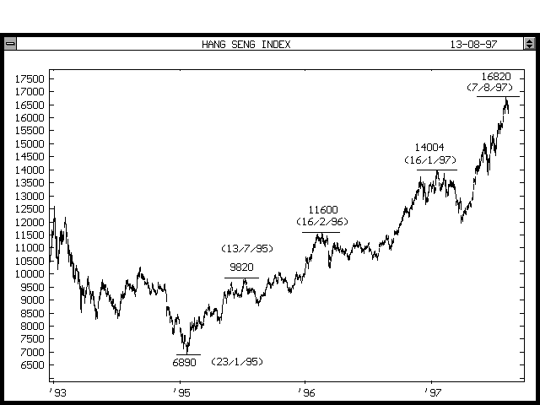
In regard to supports, major supports of Hang Seng Index are circled as below:

Chart 4 Cardinal Price Square with Hang Seng Index
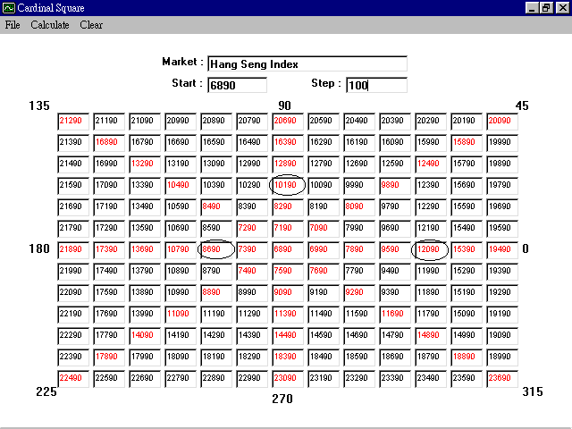
The corresponding daily chart of Hang Seng Index is as follows:

Chart 5 Support Levels on Hang Seng Index Daily Chart (93 - 97)
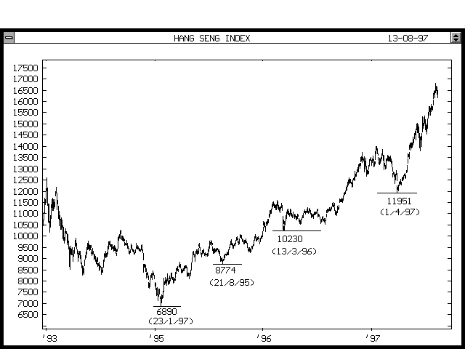
It is noted that in the same trend support and resistance levels tend to relate with each other by 0, 90, 180 or 270 degrees.

Methods and Applications of Gann Wheel

History always repeats itself, yet the relationship between the past and the future has never been revealed before W. D. Gann. Gann stipulated that in financial market market tops and bottoms are related by numbers and angles.
Gann wheel is an esoteric market analysis technique, which W. D. Gann sometimes called it the Wheel within Wheel..
Gann Wheel is a circular numerical chart, which starts with 1 from the centre and completes one cycle by filling up 24 divisions of the circle with 24 incremental numbers in an anticlockwise fashion. With expanding the process up to 15 circles, the number goes up to 360.
This chart is used to predict market support and resistance levels as well as market reversal days. The Gann Wheel is constructed as follows:
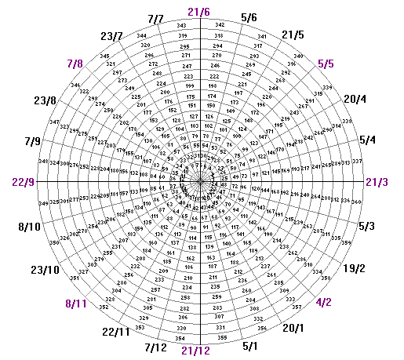

Example of Application of Gann Wheel
As all we know, the major market crash occurred in October 1987, the market fell from the all time high 337.89 on August 25, 87 to 216.47 on October 20, 87. Another major market crash occurred in July 20, 1998, the market fell from the all-time high 1,199.40 to below 1,000. See the S&P 500 futures monthly chart below:
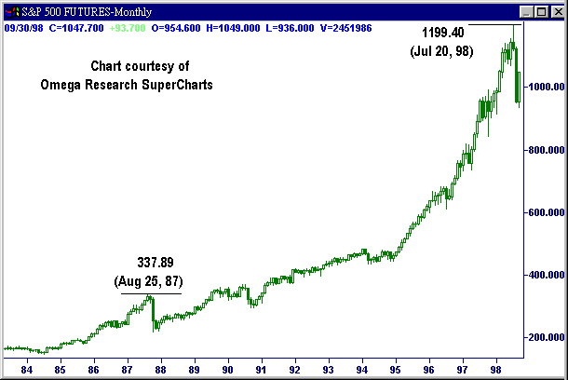
Yet, most of the contemporary financial analysts do not realized that the two major market crashes of their decades are actually related by the mathematical relationship carried in Gann Wheel.
The market top of 1987 at 337 (after conversion) located at 0 degree of Gann Wheel. According to Gann's theory, this 0 degree became the market resistance level in future. On July 20, 1998, S&P 500 futures reached the all-time high 1199.40, after conversion, the number on the Gann Wheel should be 120. Actually, the number 120 located at 360 degree of the Gann Wheel. That is, the two market tops coincide almost at the same angle on the Gann Wheel. Previous market top projected future market top at the same angular relationship.

See the Gann Wheel below:
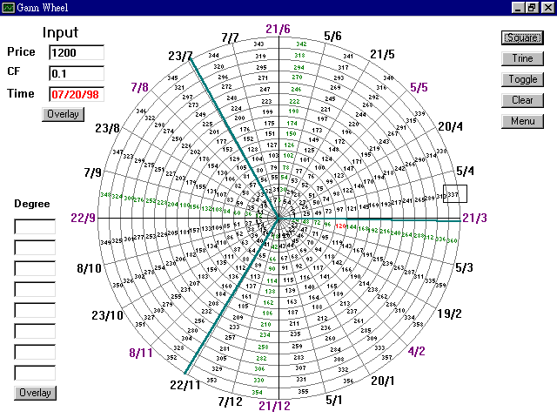
Straight enough, the "angle" of the reversal date July 20, 1998 was 120 degree (what W. D. Gann called "trine") to the "angle" of the reversal price 1199.40 (120 after conversion).
Looking at the market crash of 1987, the crash week in October 1987 was exactly 180 degrees out of phase to the all-time high 337.89 of 1987.
From the above market events, we know that market reversals are related to each other both in terms of price and time. The key is how we interpret the master piece of W. D. Gann.
<End>

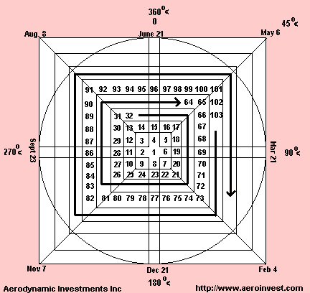

PLATONIC SOLIDS ARE IN THE GANN WHEEL
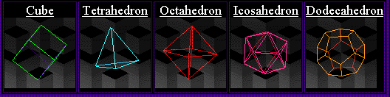

Lambert-Gann Publishing Company
www.wdgann.com

HOW TO USE A GANN WHEEL TO FIND GANN ANGLES
Gann discovered when an equality relationship occurred between time and price, a trend reversal in a market could take place. To understand this relationship it is necessary to know how a Gann Wheel can be used to calculate time or price objectives.
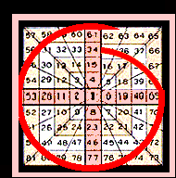
The Gann Wheel center begins at the number "1" and increases one unit clockwise. The red line shows a full rotation, or 360 degrees up from a price of 34 that would target 61.
WD Gann's analysis can be made to look extremely complex. But like Fibonacci retracements not all calculations are of interest. Let's take a closer look at the price projection technique using a Gann Wheel. Then we will define the most critical Gann angles for specific financial markets.
Draw a circle that touches all four sides of the largest square. The circle has 360 degrees to complete a full rotation. The top of the circle can be viewed as our starting point or "ground zero". Now divide the circle into equal quarters. As we move clockwise to the right corner we would cross the 45 degree angle of the circle. The first quarter at the right angle is 90 degrees and directly across from the top is 180 degrees. Continue moving clockwise until we return to the start and complete the journey around the circle at 360 degrees.

HOW IT BECOMES A CALCULATOR...
Find the number 15 on the Gann Wheel. If a stock was trading at a price of $15, what are the price objectives using a Gann Wheel? The number 15 is perfectly aligned under the zero and 360 degree angle marked on the top of the Wheel. Because the number 15 is aligned with zero we need make no further adjustments, just read the Gann targets straight off the wheel. The 45 degree price objective from 15 is 17. It is the next number that aligns with the 45 degree line that travels towards the top right corner. The number 19 crosses were the 90 degree line was drawn. We would use the phrase, "$19 is 90 degrees up from $15." Now skip over to 180 degrees and find $23 is directly opposite $15. We would still say, "23 is 180 degrees up from 15". At 270 degrees $28 is the price objective. A full 360 degrees up from 15 is $34. That is how a Gann Wheel is used.
Why did we skip the bottom right corner angle which would be 135 degrees? Because like Fibonacci, some calculations are more important than others. The Fibonacci ratios 0.382, 0.500. 0.618, 1.000, and 1.618 are relationships we know are the critical ratios to identify. This is also how the various Gann angles are interpreted. We have a circle that is divided into quarters and sixths, but we also need to divide 360 degrees into thirds because 120 degrees and 240 are extremely important. The angles of greatest interest in financial markets are 45, 90, 120, 180, 240, 270, 315, and 360.

Aerodynamic Investments Inc
South Carolina and New York City

The Gann Wheel
Octagon Chart, Pythagorean Cube, Square of 9

91 | 92 | 93 | 94 | 95 | 96 | 97 | 98 | 99 | 100 | 101
90 | 57 | 58 | 59 | 60 | 61 | 62 | 63 | 64 | 65 | 102
89 | 56 | 31 | 32 | 33 | 34 | 35 | 36 | 37 | 66 | 103
88 | 55 | 30 | 13 | 14 | 15 | 16 | 17 | 38 | 67 | 104
87 | 54 | 29 | 12 | 3 | 4 | 5 | 18 | 39 | 68 | 105
86 | 53 | 28 | 11 | 2 | 1 | 6 | 19 | 40 | 69 | 106
85 | 52 | 27 | 10 | 9 | 8 | 7 | 20 | 41 | 70 | 107
84 | 51 | 26 | 25 | 24 | 23 | 22 | 21 | 42 | 71 | 108
83 | 50 | 49 | 48 | 47 | 46 | 45 | 44 | 43 | 72 | 109
82 | 81 | 80 | 79 | 78 | 77 | 76 | 75 | 74 | 73 | 110
121 | 120 | 119 | 118 | 117 | 116 | 115 | 114 | 113 | 112 | 111

The Square of 9 is probably W.D. Gann’s most famous Master Chart. Many traders use this chart regularly
as a primary trading tool. However, it is my personal belief that most traders are only using a few simple techniques and are not fully utilizing the true potential of this multidimensional Master Calculator.

What is the Square of 9
The Square of 9 is basically a spiral of numbers starting with the number one in the center (or apex of the Great Pyramid) with the number 2 immediately to the left. The rest of the numbers spiral around the center in a clockwise fashion to the number 9, which completes the first cycle of numbers around the center. 10 through 25 completes the 2nd cycle, 26 through 49 completes the 3rd , etc… This particular arrangement of numbers creates a very unique square root relationship with other numbers on the chart. Michael S. Jenkins illustrates some interesting square root trading techniques utilizing the Square of 9 in his Gann Course and his book Chart Reading for Professional Traders. Basically, if you want to move around the coordinates on the Gann Wheel you take the number you are interested in ( such as the all time High or Low price) take the square root of the number, then add or subtract 2 from the root and resquare the result. Example: Lets say that we are interested in the price 664 (which is in the vertical column straight up from the center). The square root is 25.768 + 2 = 27.768^2 = 771 which is the number directly above 664 or one full 360 degree cycle out from center. If we subtracted 2 from the root and re-squared the number (25.768-2= 23.768^2 = 565 ) we would get 565 which is directly below 664 or one full 360 degree cycle in towards center. Incorporating the Gann Emblem with this technique, allows us to calculate coordinates that are conjunct (360 = +/- 2 from the root), opposition (180 = +/- 1 from root #), trine (120= +/- .666) (240= +/- 1.333), square (90 = +/- .5) (270= +/- 1.5) and sextile (60 = +/- .333) (300 = +/- 1.666). This technique is extremely useful for finding coordinate squares on the Gann Wheel that are making hard aspects to a previous position on the wheel. Also, Gann believed that the numbers that connected the square base of the pyramid (the 4 corners of the square, i.e. corner #’s.) to the “gravity center” and also the numbers that ran straight vertical and horizontal from the “gravity center” in the form of a cross (cardinal numbers) were very important in balancing “Price & Time” on the wheel. He was basically looking for astronomical longitudes to balance with price on these key angles. Pythagoras said “ Units in a circle or in a square are related to each other in terms of Price & Time at specific points.” Gann often quoted the Bible, Emerson, Pythagoras and Faraday to name a few. Basically, he was pointing the reader of his works to clues that would allow his student to unlock the code of his writing style.
Time
Around the outer perimeter of the Square of 9 is a circle with months and days. The circular calendar starts on the left-hand side of the wheel on the same horizontal line as the center block. The date is March 21st and refers to the start of the “natural” year in the season of Spring with the Sun in Aries ^. “Lamb of God you take away the sins of the world” ( Spring takes away the sins of Winter). The dates move around the circle clockwise completing the calendar. This relationship allows the user to quickly identify dates that are Conjuct, Opposite, Square, Trine or sextile to a past calendar date relative to the Sun / Earth relationship.

In Gann’s Master Course for Stocks he said “ Within the circle forms the square, there is an inner circle and an inner square, as well as an outer square and an outer circle which prove the Fourth Dimension in working out price movements.” So far, we have covered the inner circle ( The Earth’s Orbit around the Sun) and the inner square ( Historic high & low coordinates on the square itself). The outer circle includes all of the planets and is the Zodiac starting at the left side of the square also on March 21st. Moving from this point clockwise in 30 degree sections of the circle will place all 12 zodiac symbols around the wheel (^_`abcdefghi). This completes the outer circle and allows the analyst to examine planetary longitude relationships to price coordinates on the Square of 9, which is now an outer square. In this way, we can convert planetary positions to prices relating to degrees of a circle (Zodiac longitude) and also to coordinates on the Square of 9. We can also examine hard aspects to both zodiac longitude and Square of 9 coordinates. Furthermore, we can also use a first trade chart ( Natal Chart ), i.e. horoscope (another inner circle) to locate sensitive longitude positions that are being aspected by planets from the outer circle making them “Live Angles”! Is there any end to this multidimensional tool? Gann hinted about this natal horoscope technique in his Master Course for Stocks by saying “ The dates when companies are incorporated and the dates when stocks are first traded in on the New York Stock Exchange or the other exchanges causes them to make tops and bottoms at slightly different dates then these dates for seasonal changes”. Gann also illustrated this technique in his Soybean letter, which is well worth reading. I believe that this is what Gann meant when he discussed “Natural Law”.

Gann said “ Through the law of vibration every stock and commodity in the market place moves in its own distinctive sphere of activities,” (natal horoscope?) “ As to intensity, volume and direction. All the essential qualities of its evolution are characterized in its own rate of vibration. Stocks and commodities, like atoms, are really centers of energies, therefore they are controlled mathematically. They create their own field of action and power, power to attract and repel, which explains why certain stocks and commodities at times lead the market and turn dead at other times. Thus, to speculate scientifically it is absolutely necessary to follow Natural Law. Vibration is fundamental; nothing is exempt from its law. It is universal, therefore applicable to every class of phenomena on the globe. Thus, I affirm every class of phenomena, whether in nature or in the market, must be subject to the universal laws of causation, harmony and vibration.”

Nobody knows for certain how Gann used this Master Calculator, but If you will study this material and apply the techniques presented in this article, I think you will agree that this is how Gann probably used this tool which proves the “4th dimension in working out Time & Price movements”.
Gann Wheel 1.0 Description:
W.D Gann's marster chart This is a must have item for stock market and futures market traders. Whether trading stocks or commodities, day trading, swing trading or position trading, using technical analysis or fundamental analysis, THE GANN WHEEL will transform your trading from speculation to professional and profitable investing. THE BEST KEPT SECRET ON WALL STREET. Gann Wheel is the implementation of W.D Gann's marster chart. It includes Square of Nine, Circle of 24 and Hexagon Chat. It's a powerful tool designed to help traders to find price supports and resistances.

